[Title of Paper]
First Author’s Name and Surname^{1*}, Second Author’s Name and Surname r², & Third Author’s Name and Surname ³
^{1,2,3}Affiliation and Full Address of Author(s)
*Corresponding Author’s email

Abstract
This guide consists of instructions and format for writing the extended paper for the 1st International Conference of Sustainable Smart Cities (ICSSC 2026). The word “Abstract” should be written in bold with no more than 200 words, written in 10 pt Arial font and consist of a short background, brief description of methods, summary of results, and conclusion. The extended paper should include an introduction, materials and methods, results and discussion, acknowledgement and references sections. Figures and tables can be included and should be centered with a resolution of at least 300 dpi. The paper size should be 8.5 x 11 inches with 1-inch margins. The paper should be submitted as Microsoft Office Word (.doc) by e-mail attachment to the secretariat Email: lcsssc2026@gmail.com

Introduction
Write the full paper using Microsoft Word using Arial 11 font. To assist in writing the article, this guidance is provided in digital version, so authors can write directly in this format. For those who do not want to use this template, this guide must be read and applied to the article. The introduction should provide a clear statement of the problem, the relevant literature on the subject and the proposed approach or solution.

Methodology
The paper size should be 8.5 x 11 inches with 1-inch margins. The text should be written using Arial font. The article must be at a minimum of 4 pages and maximum of 5 pages (single-spaced) in the length excluding the references, divided in sections (e.g. introduction, methodology, results and discussions, concluding remarks) and should clearly present the problem/focus of the study, its methodology, its findings and conclusions.

Results and Discussion
Article must be research result. Figures and/or tables must be included in the results of the research. Table should be started by table title (10 pts) that set above the table. Table should be aligned at the center, and the table limit must not exceed margin of the page. If the table is more than one row, the second row should be formatted using hanging indent following the position of the first row.

Table 1 Example of table format. If the title of the table is more than one row. The second row should be formatted using hanging indent following the above limit.
Criteria | Mean | Std. Deviation | Total number of students
Course content relevance | 4.36 | 0.80 | 21
Teaching methods effectiveness | 4.38 | 0.81 | 21
Digital tools usability | 4.26 | 0.86 | 21
Instructor feedback and support | 4.31 | 0.81 | 21
Overall satisfaction | 4.34 | 0.80 | 21

Title of figure (10 pts) should be written under the figure. Figure should be centered and the resolution of scanned picture has to be not less than 300 dpi.
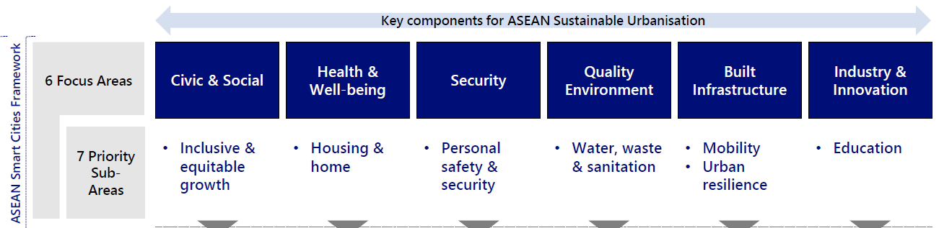
Figure 1 Title of figure (10 pts) should be written under the figure. Figure should be centered, and the resolution of scanned picture has to be not less than 300 dpi.

Conclusion

Acknowledgement

References
References (and citation style) must follow APA 7th Edition Guidelines and written alphabetically. The proposals should contain only the main references of the work (ideally, no more than eight references).

